Nathaniel Nauman
Candice Stefanou
EDUC 230: Foundations of Assessment
May 3, 2012
Assessment Project – Algebra Quiz
The purpose of this assessment was to measure the students’ (the test takers’) understanding of algebra, specifically linear and quadratic algebraic equations and their application in certain types of situations and/or problems. The algebra quiz that was used (see appendix) was developed by considering my own understanding of and past experience with algebra assessments, and the information and example algebra problems that were displayed on the two webpages listed on the references page. These two sources proved to be an excellent way for me to check the problems that were made based totally on my past experience and confirm that important topics regarding linear and quadratic algebra were not missed. These sources were also useful for giving me ideas about what kind of word problems should be included on the quiz.
The pilot testing of the algebra quiz was accomplished by giving it to 10 students in the EDUC 230: Foundations of Assessment class who were willing to take the quiz and provide informed feedback about the quiz. However one of these 10 students failed to return the quiz and so, in order to obtain a 10th quiz result for data analysis, this quiz was also given to one Bucknell Computer Engineering Sophomore who was willing to take this quiz and provide feedback. It should be noted that this student was provided with an explanation of each of the quiz critique questions that were attached to the back of the quiz so that he could provide an informed feedback about the algebra quiz. In all cases the students were given the quiz and were asked to return it to me at their earliest convenience after they had finished it. For some people, they completed the quiz immediately and returned it to me after a short period of time. While other people waited to take the quiz until it was a good time for them and then returned it to me the next time we saw each other.

Algebra Quiz Results
Student | Grade | Q.1 Points | Q.2 Points | Q.3 Points | Q.4 Points | Mean Grade
1 | 100% | 5 | 5 | 5 | 5 | 76%
2 | 95% | 5 | 5 | 4 | 5
3 | 90% | 5 | 5 | 4 | 4
4 | 90% | 5 | 5 | 3 | 5 | Median Grade
5 | 85% | 5 | 4 | 4 | 4 | 80%
6 | 75% | 5 | 5 | 4 | 1
7 | 75% | 5 | 4 | 5 | 1
8 | 50% | 5 | 0 | 4 | 1
9 | 50% | 5 | 4 | 1 | 0
10 | 50% | 3 | 4 | 2 | 1
Item Difficulty p (Max possible is 5) |  | 0.96 | 0.82 | 0.72 | 0.54
p-high (top 3 students) |  | 1.00 | 1.00 | 0.87 | 0.93
p-low (bottom 3 students) |  | 0.87 | 0.53 | 0.47 | 0.13
Item Discrimination D |  | 0.13 | 0.47 | 0.40 | 0.80
Table 1
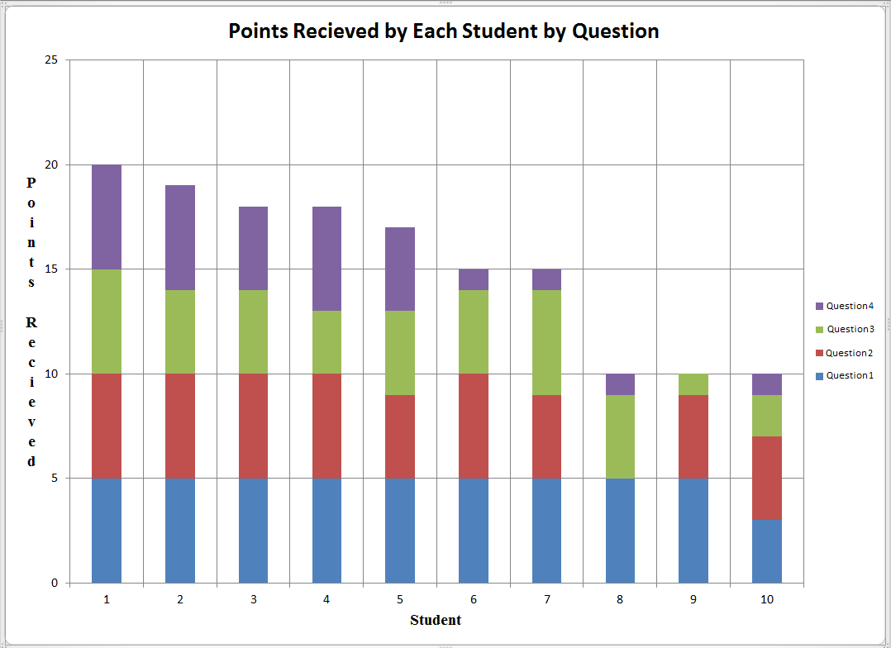
Chart 1
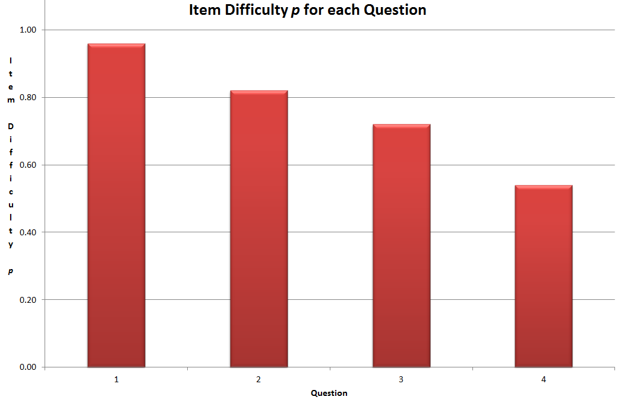
Chart 2
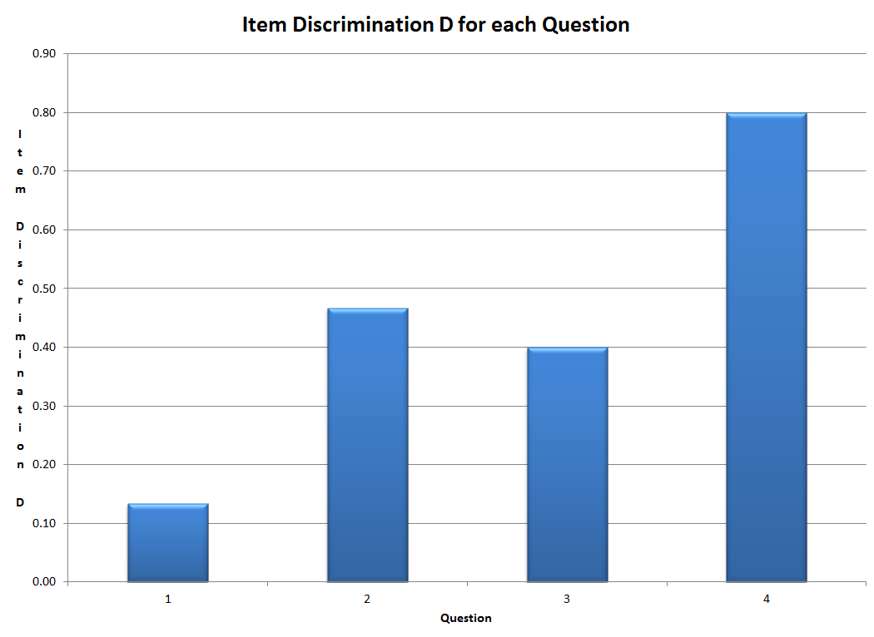
Chart 3
As can be seen in the table provided above in Table 1, the 10 students who took my quiz received overall grades at or between 100% and 50%, with the mean class grade being 76% and the median class grade being 80%. This implies that the quiz did a pretty good job at distinguishing between the high performing students and the low performing students. It also implies that the class average (whether considering the class mean or the class median) was about in the middle of the highest and lowest possible scores, although there does seem to be a slight preference for the high scoring end of the distribution, that is to say that the distribution of this data is left-skewed.
By looking at the point earnings for each question, as can be seen in Table 1 and in Chart 1, one of the first things that should be noticed is that there were a total of 5 possible points that could be received on each of the four questions that were on the algebra quiz. Now by looking at Chart 1 it can easily be seen that almost all of the students did very well on question 1, almost all students did well or very well on question 2, most students did well on question 3 but a few students really struggled with it, and about half of the students did well on question 4 while the other half did very poorly on it. So then, in order to determine the item difficulty p for each question, I let $p=\frac{number of points recieved by all of the test takers for the question}{\left(total number of test takers\right)×(5 possible points for the question)}$. By doing this it was found that p_{Q1} = 0.96, p_{Q2} = 0.82, p_{Q3} = 0.72, and p_{Q4} = 0.54, which is visually represented in Chart 2. Since each question in my algebra quiz was designed to measure student’s understanding and mastery of linear or quadratic algebra equations, the p-values that have been obtained will be compared to the mastery p-value expectations of between 0.7 and 0.8. Since p_{Q1} = 0.96 > 0.8, it can be concluded that question 1 is probably too easy of a question for the students who took the quiz. Since p_{Q2} = 0.82 > 0.8, it can also be concluded that question 2 may be too easy of a question for the students who took the quiz, although since 0.82 is close to 0.8, it is also possible that question 2 is about the right difficulty for these students. Since p_{Q3} = 0.72 and 0.8 > 0.72 > 0.7, it can be concluded that question 3 is at about the optimal difficulty for the students who took the quiz. Finally, since p_{Q4} = 0.54 and 0.7 > 0.54, it can be concluded that question 4 is probably too difficult for the students who took the quiz. Now for question 1 we can also see by looking at Table 1 that the item discrimination $D_{1}=p_{high(3)}- p_{low\left(3\right)}=1.00-0.87=0.13$, and so we can conclude by this value and by looking at Chart 3 that this question does not discriminate between the high and low test takers very much. For question 2 we can see by looking at Table 1 that the item discrimination $D_{2}=p_{high(3)}- p_{low\left(3\right)}=1.00-0.53=0.47$, and so we can conclude by this value and by looking at Chart 3 that this question does discriminate between the high and low test takers by a good bit. For question 3 we can see by looking at Table 1 that the item discrimination $D_{3}=p_{high(3)}- p_{low\left(3\right)}=0.87-0.47=0.40$, and so we can conclude by this value and by looking at Chart 3 that this question does discriminate between the high and low test takers by a good bit. Finally, for question 4 we can see by looking at Table 1 that the item discrimination $D_{4}=p_{high(3)}- p_{low\left(3\right)}=0.93-0.13=0.80$, and so we can conclude by this value and by looking at Chart 3 that this question does discriminate between the high and low test takers by a lot, so much so that it can be concluded that the lower-performing students did not really master the material covered in question 4.
From this information it is fairly easy to see that one way to improve this assessment is to make question 1 a little more difficult and to make question 4 a little less difficult, or in the case of a real class, perhaps go over the material that is related to question 4 again and emphasize the importance of everything that students seemed to really struggle with on the quiz. By considering the comments and suggestions on the algebra quiz critique paper, it can also be seen that I should have mentioned whether or not calculators could be used in the directions and perhaps made question 3 a little more clear, which could be a content validity issue. Although this may have also just been the result of some of the people who took my quiz having trouble translating the word problem into an algebra equation, which is part of the problem as well. Other than these recommendations, it should be mentioned that all of the people who took the algebra quiz thought (1) that the vocabulary that was used was good and appropriate, (2) that the frame of reference was clear, (3) that none of my questions could be offensive to anyone, and (4) that the directions that were provided were complete and easy to understand. The fifth question on the algebra quiz critique, which is about each student’s perceived algebra ability compared to what they considered to be the “average” person and compared to when they were in high school provided interesting results. These results for algebra ability self-perception are (grade – ability compared to “average” person – ability compared to high school ability): 50% – average ability – same as in high school, 50% – (not answered) – worse than in high school, 50% – a little below average – same or a little worse than in high school, 75% – worse than average – worse than in high school, 75% – above average – same as in high school, 85% – much better than average – much better than in high school, 90% – above average – about same as in high school, 90% – better than average – worse than in high school, 95% – average – better than in high school, 100% – above average – same as or a little worse than in high school. I will not go into too much detail about this information, but it is interesting and should be noted that some people who did poorly on the quiz thought that they were of average ability and that they have not gotten worse than when they were in high school while other people thought that they were really bad at or just average at math did decent or very well on the quiz, respectively. Of course this one algebra quiz is by far nowhere near enough data to determine any student’s true mathematical or algebraic ability and so it cannot be claimed that some student’s perception of their own ability is incorrect based solely on this quiz, it is just something interesting to note.
In conclusion, it is the case that the algebra quiz that was given to the 10 students has excellent face validity because it really does look like it measures algebra understanding, specifically in regards to linear and quadratic algebra equations, but has a little less content validity because question 3 is possibly not as clearly written as it could be and it is possible, as some students actually showed in their completion of this problem, to solve question 3 without or with very little algebra and just using basic mathematics (addition, division, etc.) instead. Furthermore, question 1 could and probably should be more difficult and question 4 should probably be a little easier. However, beyond these not very big issues, the algebra quiz that was given seems to be (based on student’s responses to the algebra quiz critique that was attached to the quiz) very well constructed and (based on the grade distribution of the 10 people who took the algebra quiz) seems to do a good job of assessing a student’s understanding of linear and quadratic algebra equations.

References
Sorkin, Howard. Quadratic Equation – Word Problems. http://www1.broward.edu/~hsorkin/IntWeb/Quadratic_Word_Problems.htm
The Math Page. Skill in Algebra. Lawrence Spector, 2012. http://www.themathpage.com/alg/word-problems.htm

Appendix
Algebra Quiz
Name:
Directions: Use what you learned from algebra to solve the four following problems to the best of your ability. Problems 1 and 2 are straight algebra problems and problems 3 and 4 are word problems that will require you to use algebra to solve. Full credit will require both the correct, simplified answer and the coherent display of the work that lead you to your answer. Do not forget to write down units when appropriate and please do not cheat. And remember, you can do this!
- Find x when 8x + 23 = 2 – 6x.

- Find y when y² + 4y + 11 = 5y + 27 – y.

- Janet bought a pair of shoes for $68. This cost $21 less than triple what she spent for a blouse. How much did Janet pay for the blouse?

- The length of a rectangle is 13 inches more than its width. The area of the rectangle is 68 square inches. Find the dimensions of the rectangle. (Hint: Area = Length × Width.)

Algebra Quiz Critique
- Vocabulary—Is the language that I used at a level that is consistent with the vocabulary of High School Algebra Students?

- Frame of Reference—Did you understand what it was that I was trying to measure? If not, then explain. Did you know what I was referring to when I asked my questions?

- Sensitive Questions—Do you think that the phrasing of my questions could possibly offend any high school students? Did they offend you?

- Directions—Given the directions that I gave you, were you able to do what I asked you to do? Were the directions easy to understand? Were they complete?

- Algebra Ability—How well would you say your algebra skills are now (relative to the “average” person)? How would you say your algebra skills are now compared to when you were taking algebra in High School? (Scale: Much Better – Better – Average – Worse – Much Worse)

